1. How to add an element at a specific position in an ArrayList (create using <>)
2. Create an array of employee objects and iterate through it and remove the object at the 2nd position.
3. Create a HashMap type and display the elements using the keyset()
4. Create a Set type and check if it holds any duplicate value. Work on both TreeSet and HashSet
5. Write a program to sort the employee objects using the Comparable and Comparator.

ANSWERS

1.



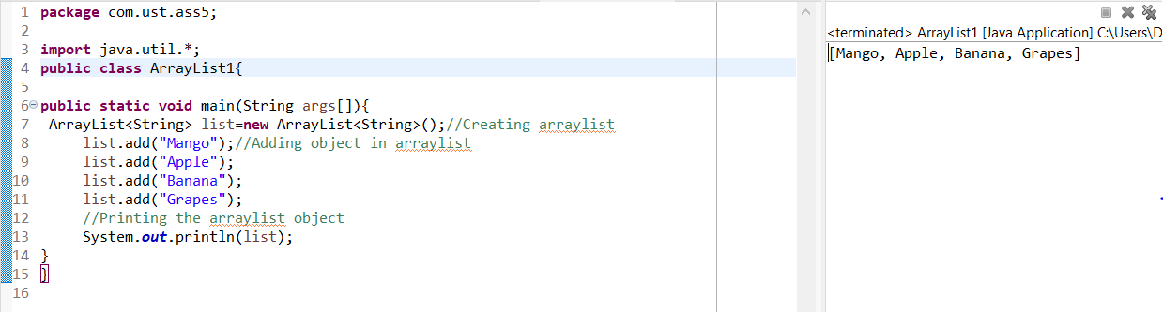

2.



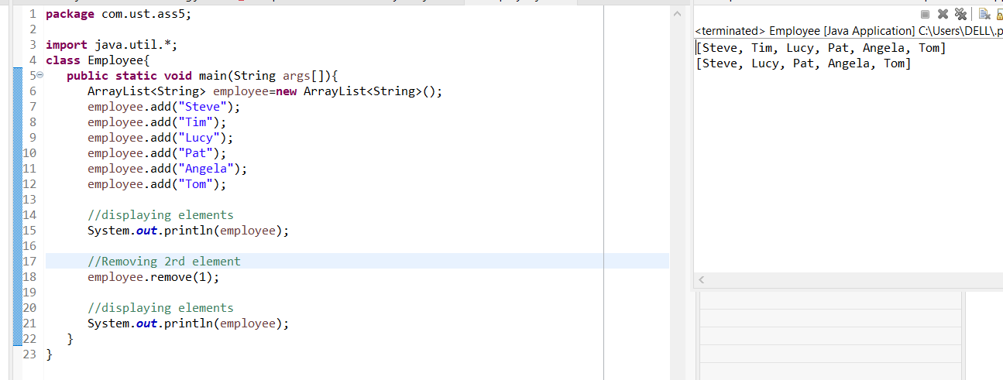

3.



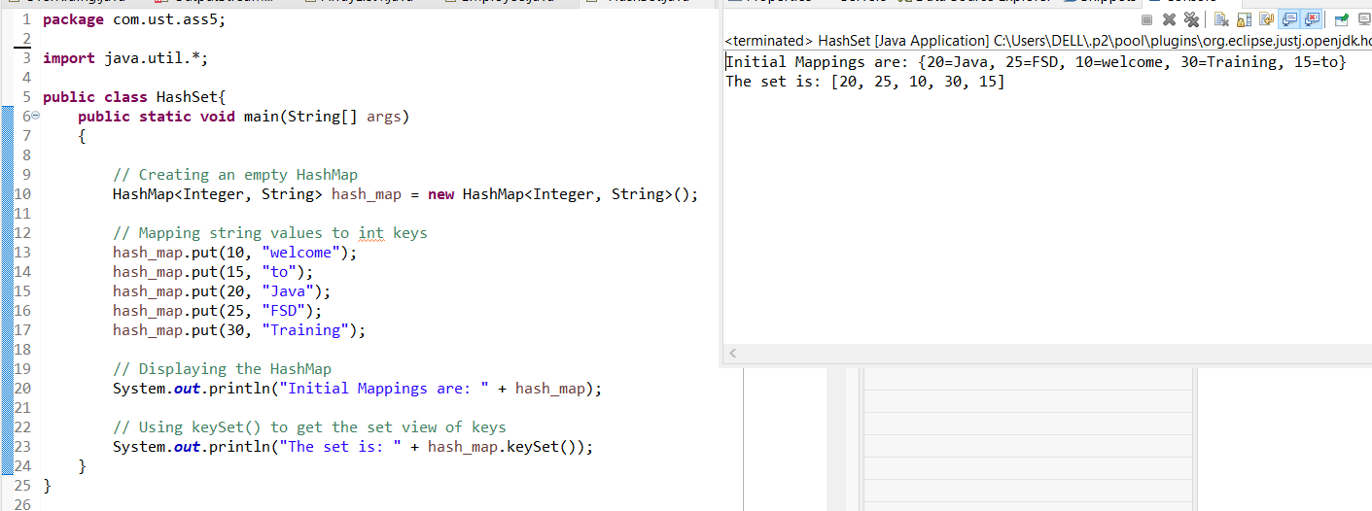

4.



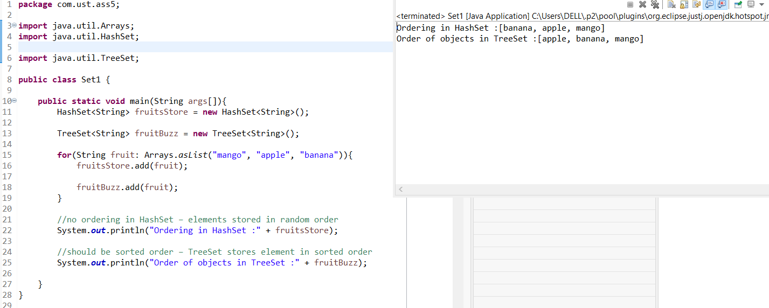

5.



